EMBEDDED SYSTEMS LAB
FAROOQ AHMAD EXPERIMENT # 8
17L-4407 LAB REPORT # 8
EL-7B

INTERRUPTS

INTRODUCTION
In this lab session, we were introduced to interrupts. An interrupt is the automatic transfer of software execution in response to a hardware event that is asynchronous with the current software execution. This hardware event is called a trigger. On the ARM ® Cortex™-M processor, exceptions include resets, software interrupts and hardware interrupts. Each exception has an associated 32-bit vector that points to the memory location where the ISR that handles the exception is located. Vectors are stored in ROM at the beginning of memory.
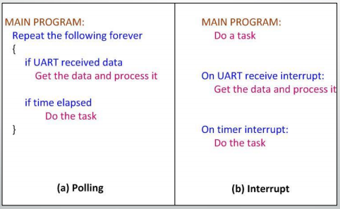
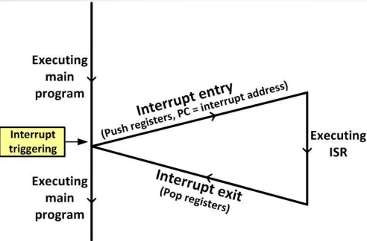

OBJECTIVE
The course learning objective of this lab session was to learn about interrupts of TM4C and to understand concept of NVIC in TM4C.

PROCEDURE
• Enable interrupt for a specific peripheral module using interrupt mask (IM) register. In case of GPIO, GPIOIM is used. The lower 8 bits of 32 bit register are used to enable/disable for specific pin of port.
• Enable interrupts at NVIC module. There is an interrupt enable for each entry in the interrupt vector table. These enable bits are in the registers EN0 to EN3 in NVIC. Each register convers 32 IRQ interrupts. • Enable interrupt globally by assembly language instruction CPSID I and CPSIE I
• Priorities can be set to each interrupt before enabling them. For each IRQ number there is one byte corresponding to that IRQ to assign its priority. The allowed priority levels are ranging from 0 to 7 and they are defined by three bits left justified in that byte. PRIn register is used for this purpose.
• Interrupt trigger point for an I/O pin can be chosen from
o Lowe level
o High level
o Rising edge
o Falling edge
o Both edges
It can be chosen from GPIOIS and GPIOIEV registers. Edge/level sensitive can be chosen from IS register and falling/rising can be chosen form IEV register.
• ISR should clear respective bits in GPIOICR before exit, otherwise interrupt will be called again and again
Interrupt Handler Routine:
• Open startup file
• Locate handler routine and rename it with your desired name
• Using “extern” mention that this routine is written in another code file (i.e., your main .c file)
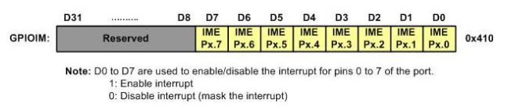
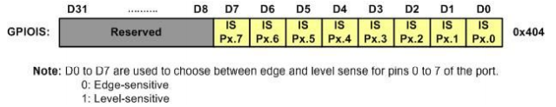
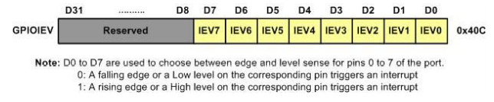
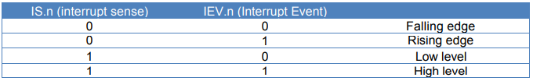
LAB TASKS:
1. Implement a traffic control system. There is a single Traffic light whose lights turn on after every second. When traffic flow is less say after midnight, SW1 is pressed and yellow lights starts to blink with 1KHz rate. Another scenario is when traffic police takes over and turn off the traffic light. This scenario is triggered by pressing SW2. Write interrupt driven code for this problem. In order to go back to normal mode from any scenario, same switch is pressed again. Both switches are at the same priority level.
2. Modify code such that if both switches are pressed at the same time, interrupt of SW2 is handled first.

ISSUES
There were no issues.

CONCLUSION
This lab session was conducted successfully. Interrupts are basically internal/external signals that suspend the main routine being done/executed. An interrupt is a special condition that arises during the working of a microprocessor. The microprocessor services it by executing a subroutine called Interrupt Service Routine (ISR). Interrupts on the Cortex-M are controlled by the Nested Vectored Interrupt Controller (NVIC). To activate an interrupt source, we need to set its priority and enable that source in the NVIC. Interrupt numbers 0 to 15 contain the faults, software interrupt and SysTick. Rest of the interrupts are hardware IRQ interrupts.

APPLICATIONS
Interrupts are commonly used to service hardware timers, transfer data to and from storage (e.g., disk I/O) and communication interfaces (e.g., UART, Ethernet), handle keyboard and mouse events, and to respond to any other time-sensitive events as required by the application system. Non-maskable interrupts are typically used to respond to high-priority requests such as watchdog timer timeouts, power-down signals and traps. Interrupt prioritization is important in determining the order of execution when two or more interrupts occur simultaneously. Here it’s the importance, urgency, and frequency of tasks that decide the priority. Applications of interrupts include the following: system timers, disk I/O, power-off signals, and traps. Other interrupts exist to transfer data bytes using UARTs or Ethernet; sense key-presses; or anything else the equipment must do.
Another typical use is to generate periodic interrupts by dividing the output of a crystal oscillator and having an interrupt handler count the interrupts in order for a processor to keep time.

POST LAB
#include <stdint.h>
#include "inc/tm4c123gh6pm.h"

void DisableInterrupts(void);
void EnableInterrupts(void);
void WaitForInterrupt(void);
void GPIOPortF_Init(void);
void GPIOPortF_Handler(void);
void delayMs(int);

void GPIOPortF_Init(void)
{
SYSCTL_RCGC2_R |= 0x00000020; /* 1) activate clock for PortF */
GPIO_PORTF_LOCK_R = 0x4C4F434B; /* 2) unlock GPIO PortF */
GPIO_PORTF_CR_R = 0x1E; /* allow changes to PF4-0 */
GPIO_PORTF_AMSEL_R = 0x00; /* 3) disable analog on PF */
GPIO_PORTF_PCTL_R = 0x00000000; /* 4) PCTL GPIO on PF4-0 */
GPIO_PORTF_DIR_R &= 0xEF; /* PF4 output 1110_1111*/
GPIO_PORTF_DIR_R |= 0x0E; /* make PORTF3, 2, 1 output for LEDs */
GPIO_PORTF_AFSEL_R = 0x00; /* 6) disable alt funct on PF7-0 */
GPIO_PORTF_PUR_R = 0x10; /* enable pull-up on PF0 and PF4 */
GPIO_PORTF_DEN_R = 0x1E; /* 7) enable digital I/O on PF4-0 */

//interrupt related settings
GPIO_PORTF_IS_R &= ~0x10; /* PF4 is edge-sensitive */
GPIO_PORTF_IEV_R &= ~0x10; /* PF4 falling edge event */
GPIO_PORTF_ICR_R = 0x10; /* Clear flag4 */
GPIO_PORTF_IM_R |= 0x10; /* arm interrupt on PF4 */

NVIC_EN0_R = 0x40000000; /* Enable interrupt 30 in NVIC */

EnableInterrupts(); /* Enable global Interrupt flag (I) */

}

void GPIOPortF_Handler(void)
{
int i;
volatile int readback;
/* toggle green LED (PF3) three times */
GPIO_PORTF_DATA_R &= 0xF1;
for (i = 0; i < 3; i++)
{
GPIO_PORTF_DATA_R |= 0x08;
delayMs(500);
GPIO_PORTF_DATA_R &= ~0x08;
delayMs(500);
}

GPIO_PORTF_ICR_R = 0x10; /* clear interrupts */
readback = GPIO_PORTF_ICR_R; /* a read to force clearing of interrupt flag */

}

/* delay n milliseconds (16 MHz CPU clock) */
void delayMs(int n)
{
int i, j;
for(i = 0 ; i < n; i++)
for(j = 0; j < 3180; j++)
{} /* do nothing for 1 ms */
}

int main(void)
{
GPIOPortF_Init(); /* initialize GPIO Port F interrupt */

while(1){
GPIO_PORTF_DATA_R &= 0xF1;
GPIO_PORTF_DATA_R |= 0x02;

delayMs(500);
delayMs(500);
GPIO_PORTF_DATA_R &= 0xF1;
GPIO_PORTF_DATA_R |= 0x04;
delayMs(500);
delayMs(500);
GPIO_PORTF_DATA_R &= 0xF1;
GPIO_PORTF_DATA_R |= 0x08;
delayMs(500);
delayMs(500);
}
}

/*********** DisableInterrupts ***************
*
* disable interrupts
*
* inputs: none
* outputs: none
*/

void DisableInterrupts(void)
{
__asm(" cpsid i\n" );

}

/*********** EnableInterrupts ***************
*
* enable interrupts
*
* inputs: none
* outputs: none
*/

void EnableInterrupts(void)
{
__asm( " cpsie i\n");

}

